**CREATE NODE-RED SERVICE**

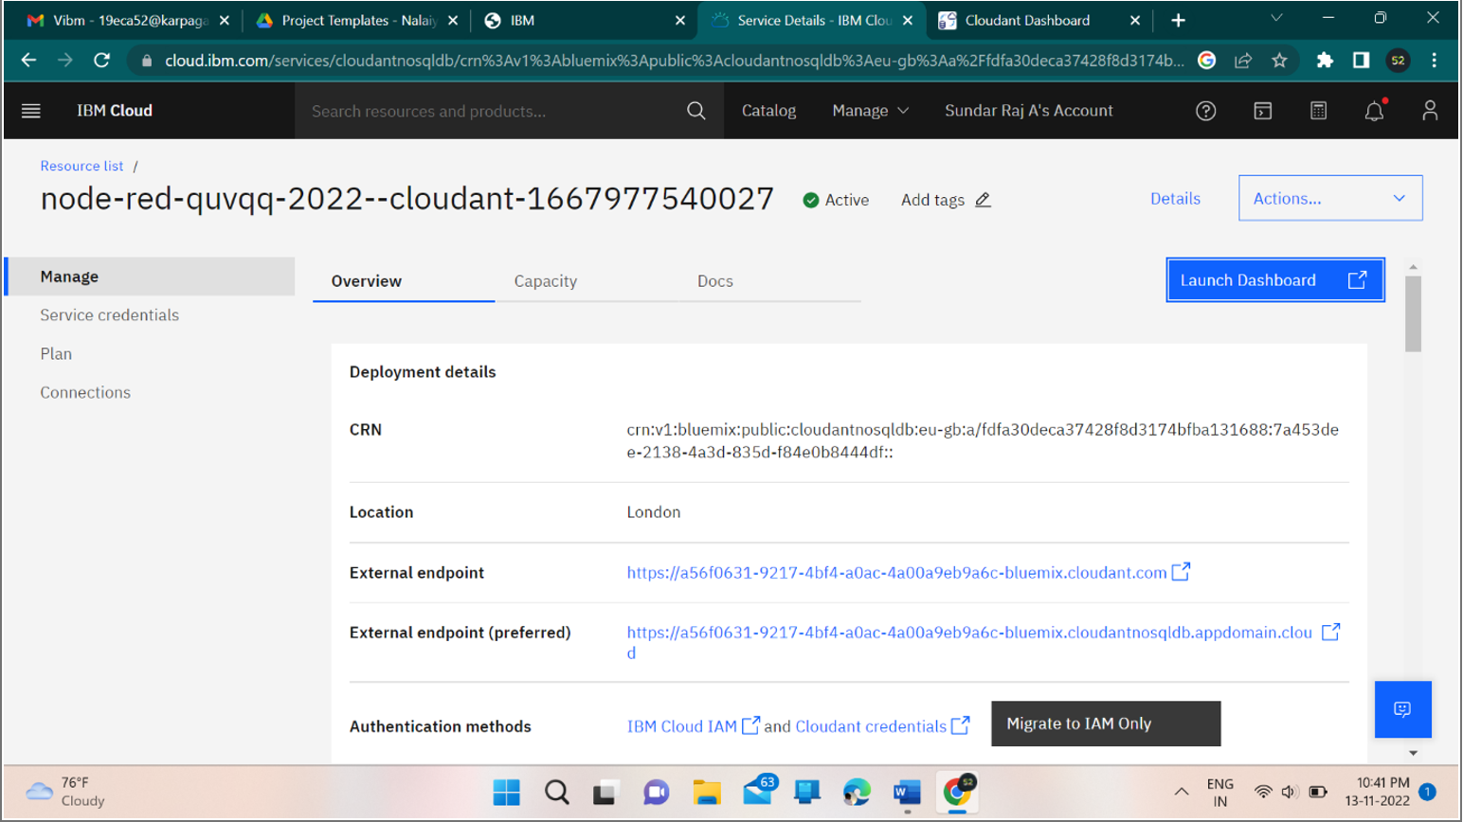

**CREATING NODE-RED SERVICE SUCCESSFULLY**